
YISHUN INNOVA JUNIOR COLLEGE
JC 2 PRELIMINARY EXAMINATION
Higher 2

CANDIDATE
NAME

CG |  |  |  |  |  |  | INDEX NO

GEOGRAPHY  Paper 2  INSERT | 9173/02 (REVISED)  12th September 2024  3 hours

READ THESE INSTRUCTIONS FIRST
This Insert contains all the Resources referred to in the questions.

INSERT

This document consists of 8 printed pages.

Resource 1 for Question 1

Map showing the 2 sites for the Fieldwork

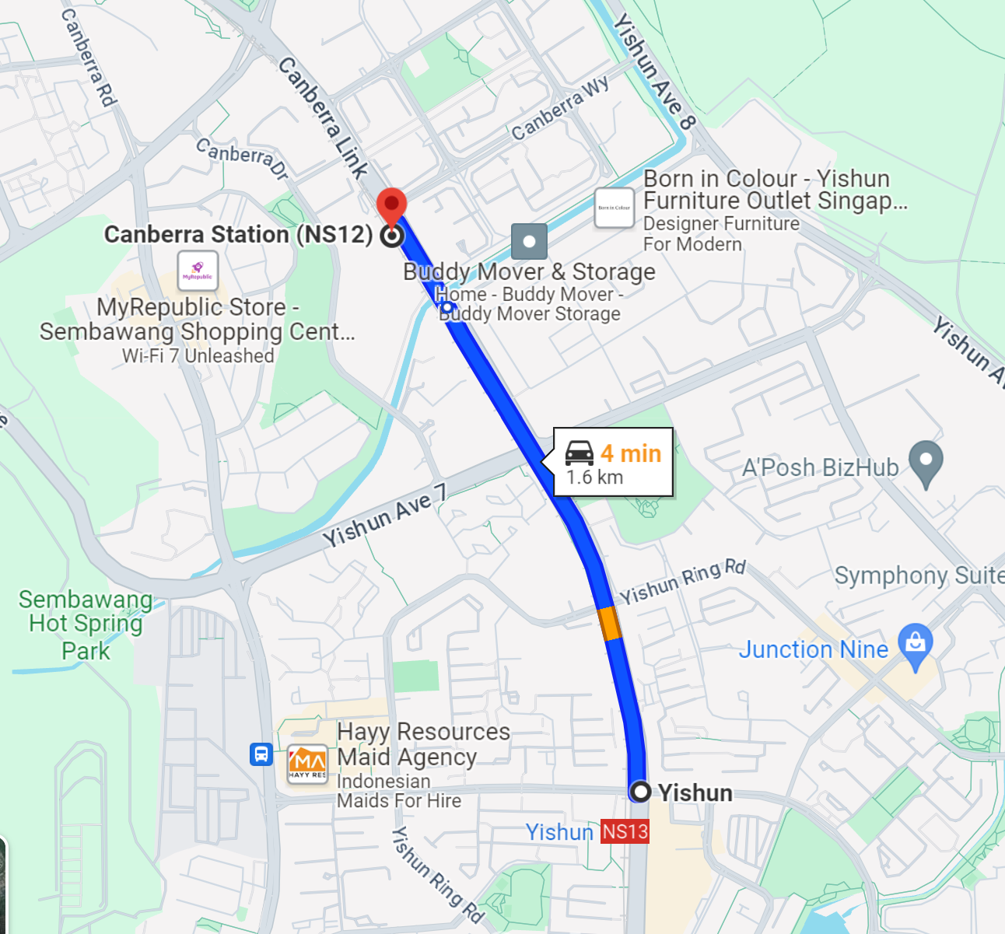

Yishun
Canberra

Resource 2 for Question 1
Photographs taken during the students' on-site field inspection of Canberra estate demonstrating awareness of sustainability issues

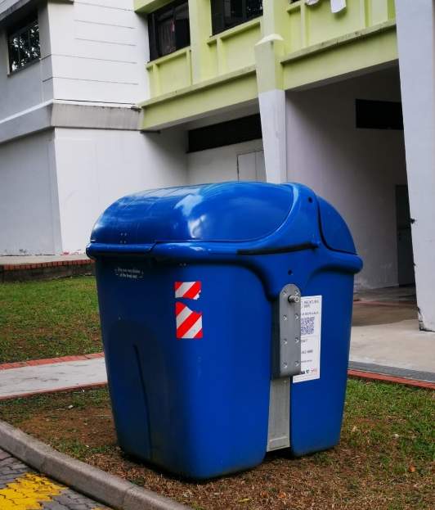  Recycling bins found at every block |  | 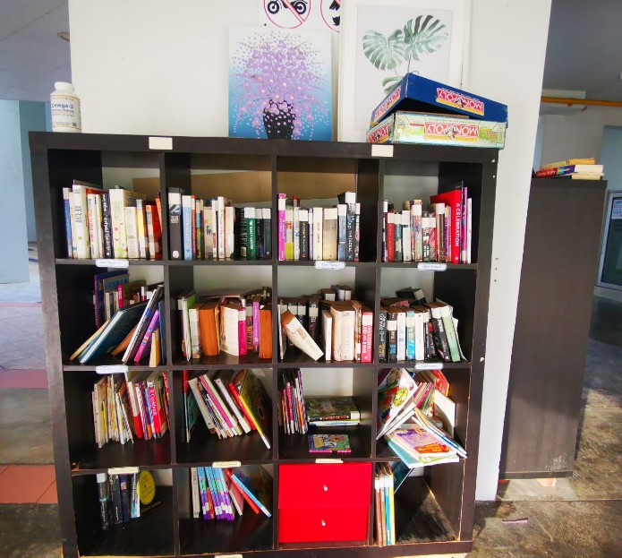  Book exchange corner found near the letter box of one block of flats
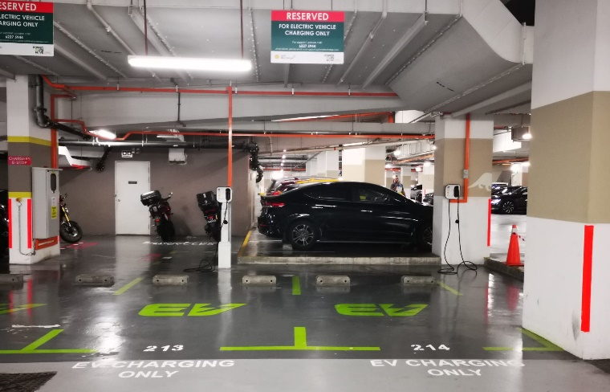  Electric Vehicle (EV) charging points found at basement  of Canberra Plaza (next to the Canberra MRT station) |  |  | 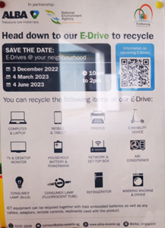  E-Drive poster to encourage recycling found at lift lobby of one block of flats
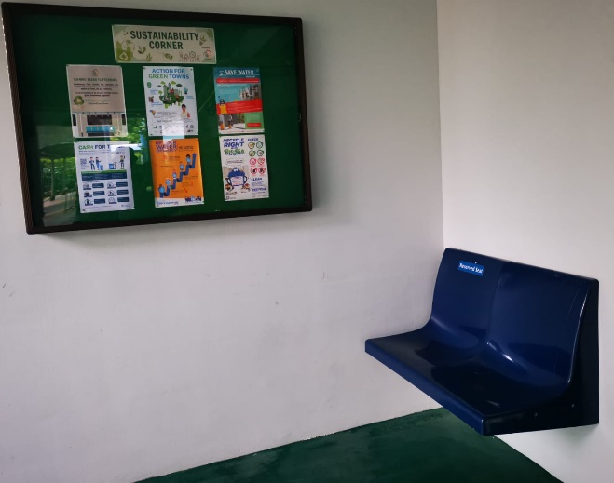  Upcycled train seats found at a  sustainability corner of a void deck | 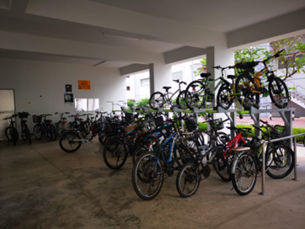  Bicycle parking facilities found at  several places in the estate

Resource 3 for Question 1

Data recording sheet for the survey

Profile of respondent :

- How often do you switch on the air-con at home? Never/not often/Quite often/Very often

- How often do you use car sharing/public transport? Never/not often/Quite often/Very often

- Do you take any actions to reduce environmental degradation? No/Yes

- What actions do you take to reduce environmental degradation? __________________________

Resource 4 for Question 1

Survey findings

- How often do you use the air con at home?

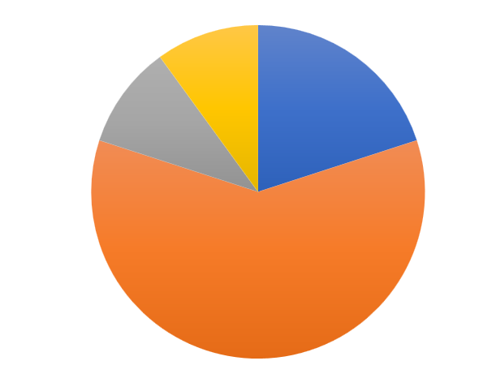  8% 8%  17%  67%  Yishun | 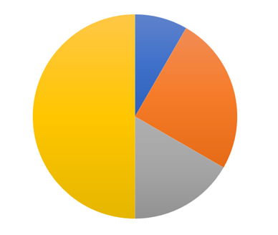  Canberra  8%  50% 25%  17% | 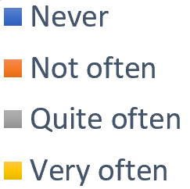

- How often do you use car sharing/public transport?

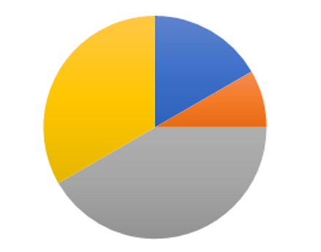  Yishun  33% 17%  8%  33% | 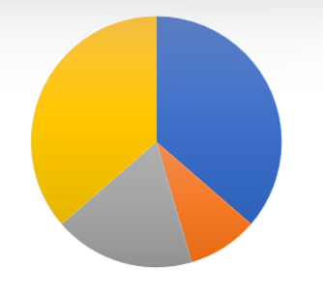  Canberra  25% 8%  33% 33% | 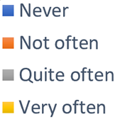

- Do you take any actions to reduce environmental degradation?

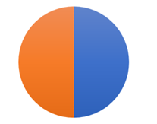  Yishun | 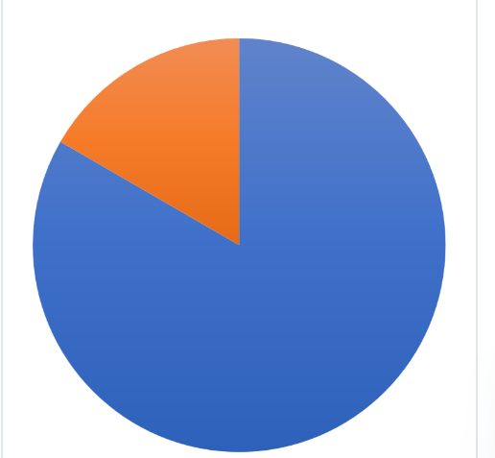  Canberra  50% 50% 17% 83% | 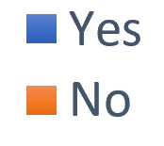

Resource 5 for Question 2

Environmental Sustainability Data, Green Cities of the World
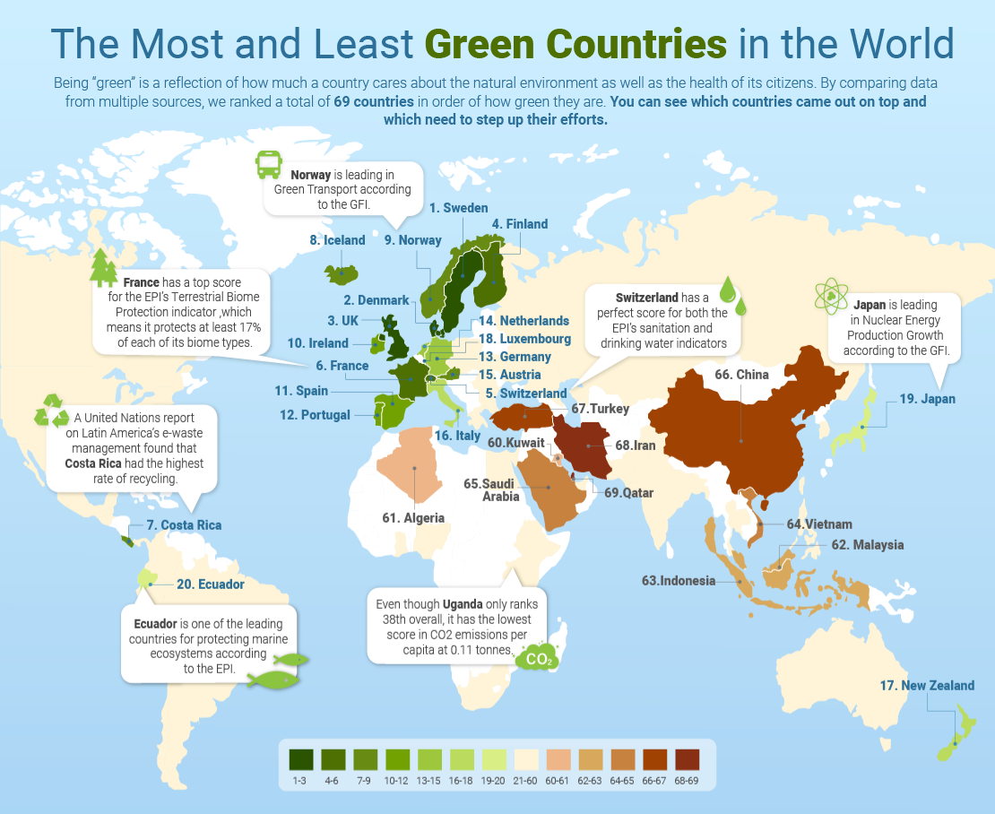

Resource 6 for Question 2
Best Cities to live in China

Name of City | Average Cost of Living Per Month (US$) | Safety (over 10 points) | Nightlife (over 10 points)
Nanjing | 820 | 8/10 | 8/10
Shanghai | 1950 | 9/10 | 10/10
Shenzhen | 1650 | 9/10 | 7/10
Qingdao | 1300 | 9/10 | 7/10

Resource 7 for Question 2

Most Liveable Cities of India

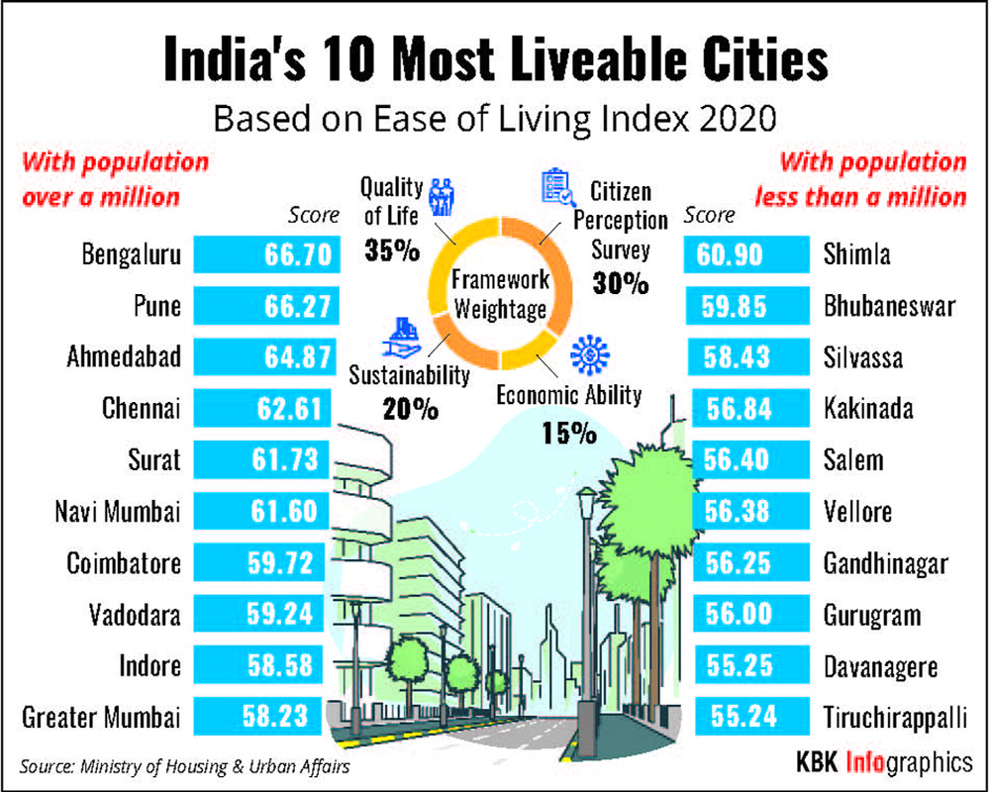

Resource 8 for Question 2

Resource 8A
Sexual Harassment of Women in the EU

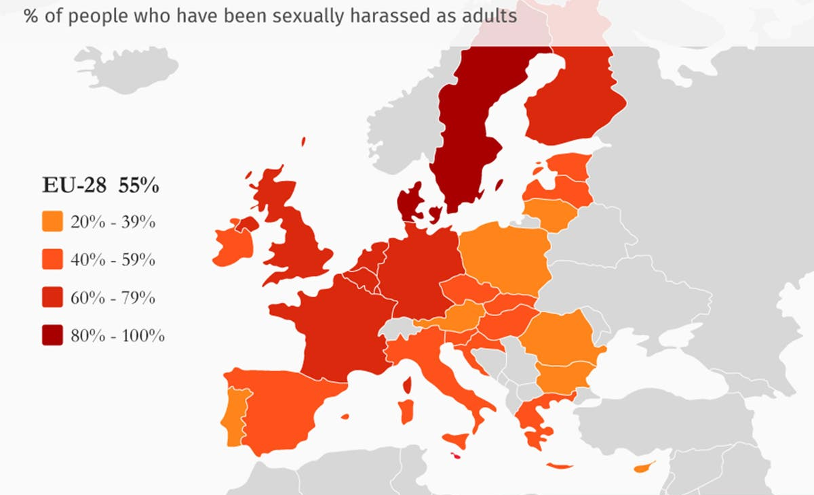

Resource 8B
Map showing the countries in EU
